

Resources For Home

The following websites are wonderful resources for you to use at home or at the public library! Isn’t great to have fun while learning?



**Go Math! Here you will find a huge array of resources. MegaMath has tons of fun games for all math topics. There are iTools to help you visualize and play with the math concepts and even online (and printable!) copies of our Student Textbook, Enrichment sheets, and Practice worksheets. You’ve got it all right at your fingertips.**

[www.thinkcentral.com](http://www.thinkcentral.com) 🡪Mathematics 🡪Go Math! Florida 🡪Florida, Leon County, Gilchrist

Username: _Student Number@edu.leonschools.net_ Password: _____Lcs6789!____

.

[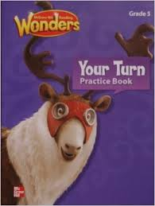](http://www.google.com/imgres?imgurl=http://ecx.images-amazon.com/images/I/41d6LhVjj2L._SX258_BO1,204,203,200_.jpg&imgrefurl=http://www.amazon.com/McGraw-Hill-Reading-Wonders-Grade-Practice/dp/0021192243&h=345&w=260&tbnid=X9jazonIl5iaRM:&zoom=1&docid=bOARU_0qWp3bBM&hl=en&ei=9MfrU_2BPeHisAS94oGYAg&tbm=isch&ved=0CEAQMygcMBw&iact=rc&uact=3&dur=369&page=1&start=0&ndsp=29)

WONDERS! Online is a great resource to access your textbooks from home (you can also play interactive games with the skills we are learning in class.)

<http://connected.mcgraw-hill.com/connected/login.do>

Username: lcsb _ student id Password: ___lcs12345__

(Ex: lcsb_ 171…….)

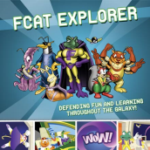**FCAT Explorer - Now this site is where the fun really starts!! The experts did a great job making learning seem like playing! Remember that your goal is to finish both the Math and Science sections before the FSA rolls around. For reading, try the 6th grade link.**

[www.fcatexplorer.com](http://www.fcatexplorer.com) Username: ____Student Number_ Password: ___Student Number______

*\*Your username and password should be the same as Pearson unless I have specifically given you another.*

Edmodo provides a safe and easy way for your child to connect and collaborate, share questions with the teacher, access homework, and receive school notices. Each teacher has their own access code so students can get valuable information about each class.



[www.edmodo.com](http://www.edmodo.com)

USERNAME: Student number PASSWORD: Student number

Ex: hbryant@gilchrist

This website keeps record of your classroom behavior! Please check it often!!

Username: ________ Password: ______

[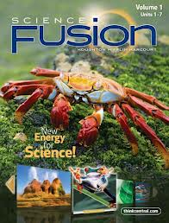](http://www.google.com/imgres?q=science+fusion+5th+grade&um=1&safe=active&hl=en&biw=1280&bih=875&tbm=isch&tbnid=ofDphWdwt3mZfM:&imgrefurl=http://www.kno.com/book/details/science-fusion-grade-5-vol-1?productId=txt9780547783900&docid=bEQeD2HRfahvMM&imgurl=https://www.kno.com/images/book-jackets/9780547783901.jpg&w=581&h=765&ei=HD1EUqHVBoG69QSdkoCABw&zoom=1&ved=1t:3588,r:1,s:0,i:82&iact=rc&page=1&tbnh=222&tbnw=196&start=0&ndsp=28&tx=141&ty=110)

Houghton Mifflin created a science text book that allows students to interact with

the text. There is not only a student text but also online interactive

virtual labs to further investigate concepts .

[www.thinkcentral.com](http://www.thinkcentral.com) Student Number@edu.leonschools.net_ Password: _____leon6789!____



IXL provides comprehensive, standards-aligned math and language arts

practice for K–12.

[www.ixl.com/signin/gilchrist](http://www.ixl.com/signin/gilchrist) Username: ___ @gilchrist _Password: ____bears1__



.

<http://www.classdojo.com>

**CLASS WEBPAGE:** [**www.leonschools.net/gilchrist**](http://www.leonschools.net/gilchrist)



**\*Please don’t tuck me away!**

**Stick me up somewhere safe where you can’t miss me ☺ \*\***